Appendix S1.
Functions and parameters used to construct integral projection models for 6 Vietnamese tree species

- Relating vital rates to diameter at breast height (d.b.h.)
We used vital rates values for the full 2-year period between the first and last census, as no differences in vital rates were found between years. We used the Hossfeld IV equation (Zeide 1993) to relate d.b.h. growth (Δdbh, cm y⁻¹) to d.b.h. (cm):
b x c x dbh^{(c-1)}
[b + (dbh^{c}/a)]²
Δdbh =
(S1)

where a, b and c are fitted parameters. The functions were fitted using non-linear regression analysis with a least-square loss function. We then related residuals around these curves to d.b.h. in order to detect size-dependency in growth variation, using various types of (non-)linear regression.
We applied logistic regressions to relate survival and reproductive status to d.b.h.. The number of recruits per reproductive tree was calculated as quotient of abundance of new seedlings (ha⁻¹ y⁻¹) and abundance of reproductive trees (ha⁻¹).

- Resulting functions and parameters
The logistic regressions that related survival to d.b.h. proved to be non-significant (p>0.05), but we included some size-dependency in survival. Parameters of fitted functions are included in Table S1. Resulting functions for survival, growth and reproduction are shown in Figure S1.

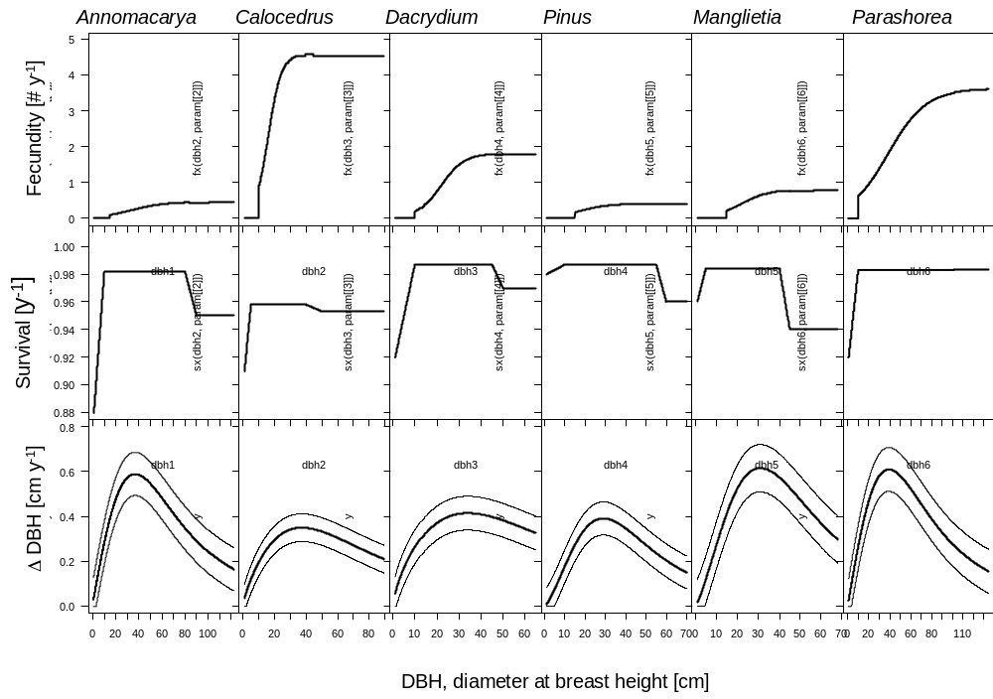
Figure S1. Size-dependent relations of vital rates for six Vietnamese tree species. Upper panels. The fecundity relations correspond to functions F(y,x) and denote the number of recruits (seedlings) of size y (<30 cm height) produced per tree of size x (d.b.h.). The function is based on the relation of reproductive status and d.b.h. (logistic regressions), and the number of recruits produced per reproductive adult (see Chien et al. 2008). Reproduction did not occur below a threshold size of 15 cm d.b.h. in Annamocarya, Pinus and Manglietia and of 10 cm d.b.h. in Calocedrus, Dacrydium and Parashorea. Middle panels. Survival relations correspond to s(x) and denote the annual survival probability for an individual of size x. No significant relations between survival and d.b.h. were found using logistic regressions, probably due to small sample sizes. We implemented slightly lower survival probabilities for small trees as this is realistic (cf. Condit et al. 2000) and for larger individuals as this yielded a closer match between observed and stable size distribution (right eigenvector of K). Lower panels. Δdbh relations are based on Hossfeld IV equations (eq 1) and give the annual d.b.h. growth for trees of size x. Thin lines denote1 SD around the curve for average growth. As no size-dependency was found of the residuals around the mean curves, the SD lines run parallel to the mean curve.

Table S1. Parameter values used to construct the projection kernel. Included are fitted parameters for the nonlinear Hossfeld equation (included above) including the standard deviation (SD) of the residuals, the fitted parameters for the binomial logistic regression that relates reproductive status with d.b.h., and the annual number of seedlings produced per reproductive adult tree (#Sdl/repro).
Species | Hossfeld |  |  |  | Reproductive status |  | #Sdl / repro
 | a | b | c | SD | constant | slope | #Sdl / repro
Annamocarya sinensis | 59.1 | 65.8 | 1.982 | 0.0964 | -2.32 | 0.069 | 0.47
Calocedrus macrolepis | 42.9 | 51.9 | 1.778 | 0.0618 | -3.838 | 0.24 | 4.78
Dacrydium elatum | 50.7 | 30.0 | 1.696 | 0.0753 | -4.027 | 0.187 | 1.835
Manglietia fordiana | 24.3 | 233.5 | 2.292 | 0.0738 | -2.396 | 0.139 | 0.417
Parashorea chinensis | 42.1 | 144.0 | 2.258 | 0.1054 | -3.232 | 0.146 | 0.829
Pinus kwangtungensis | 64.1 | 72.3 | 1.999 | 0.0982 | -2.114 | 0.055 | 3.679

- Constructing the kernel
The general equation for integral projection models (IPMs) is similar to those for matrix models: n(t+1) = K n(t), in which K is a square transition matrix of with m categories of width h (Ellner & Rees 2006, eq 2 in main text). In our IPMs the demographic kernel K consisted of 4 discrete seedling classes and a continuous d.b.h. scale range from 1 cm d.b.h. to 5% larger than the maximally observed d.b.h.. Four different sections can therefore be distinguished in K: 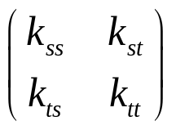
In which the first column represents the 4 discrete classes with transition contributions made by seedlings (s), and the second column represents the continuous size scale with size-dependent transition contributions made by trees (t).
- The transitions among the seedling classes (i.e. the 4x4 k_{ss} section) were exactly the same as in Chien et al. (2008).
- The section k_{tt} (i.e. a continuous kernel of probabilities defining the transitions of individual trees of any d.b.h. size to any d.b.h. size the next year, function P) is determined by the product of the size-dependent survival (S) and growth (G) functions: P(y,x) = S(x) * Z(y,x) in which y is size at t+1, x is size at t. Survival function S is shown in Figure S1 (middle panels). The new-size function Z for surviving trees is implemented as Z(y,x) = x + G(x), in which G(x) is a normal distribution. The mean of G(x) depends on size x and is given by the Hossfeld IV regression equations in Fig. S1 and Table S1 above. The standard deviation of G(x) did not vary across x and is therefore constant as can be seen in the lower row of panels of Fig. S1.
- The section k_{st} contains the reproduction transitions of trees on a continuous size scale to the number of new seedlings in the first seedling class, given by a product of 1) the size-dependent survival function (Fig. S1), 2) the function of size-dependent probability of reproduction (Table S1) and 3) the number of new seedlings per reproductive tree (Table S1). The second to fourth rows of the k_{st} section contain only zeros.
- The section k_{ts} contains the probabilities that seedlings grow bigger than 1 cm d.b.h., after which they are no longer considered to be a seedling and are characterized by their d.b.h. rather than by their height. Only some seedlings in the fourth height class made this transition and the first three columns of section k_{ts} therefore contain only zeros. The probability of seedlings of height class 4 surviving and growing thicker than 1 cm d.b.h. is given by matrix element a₅₄ in Chien et al. (2008). The d.b.h. of those former seedlings is given by a normal distribution that is capped at 1cm at the lower side, and then rescaled to sum to 1. The means and standard deviations of those normal distributions were estimated from next-year d.b.h. size of seedlings in the fourth seedling class: 1.068±0.377 for Annamocarya, 1.051±0.154 for Calocedrus, 1.073±0.286 for Dacrydium, 0.871±0.211 for Pinus, 1.081±0.414 for Manglietia and 1.078±0.369 for Parashorea.

- From kernel to transition matrix
In order to perform matrix algebra to obtain the projected population growth rate λ and elasticities we need to evaluate the kernel as a transition matrix (Ellner & Rees, 2006). This transition matrix needs to possess a sufficiently large number of categories such that it represents the continuous IPM kernel smoothly enough: increasing the number of categories further (and thereby further reducing the category width) should not influence the output of the model noticeably. Translating a continuous IPM into a discrete and large transition matrix is customarily done by applying the so-called ‘mid-point rule’. This method uses the value of the vital rate functions at the midpoint of a category of width h to represent these vital rates across the entire width of that category. The category width h should then be chosen such that the assumption that the midpoint-value is representative for the entire category. As discussed in the main text, in the case of large trees with little annual growth, applying the midpoint rule would require very narrow categories and therefore transition matrices that are too large to be computationally practicable.
Therefore we used an integration method rather than the mid-point method to determine the growth rates: instead of the mean probability that an individual in a size class reaches the lower boundary of the next size class, we used the integral of the new-size function Z(x,y) over the range of sizes x in a class. That means that for all sizes x within a category we calculated the probability that individuals end up in particular size categories, and then averaged those probabilities per size category y. In R this could probably be done sophistically with the ‘integrate’ function, but here we approximated the integration by calculating the new-size probabilities for many initial sizes xx:

xx<-seq(from=x[j]-h/2,to=x[j]+h/2,length=200)
z<-numeric(0,m)
for (i in (m:(j+1))) {
muxx<-xx+hossfeld(xx,a,b,c)
z[i]<-mean(1-pnorm((y[i]-h/2),mean=mux,sd=sd.hossfeld))-sum(z)
}
z[j]<-1-sum(z)

In this code x[j] and y[i] are the midpoints of an m by m matrix with h wide categories. The code calculates the new-size (z) distribution for individuals in the j^{th} size (x) category. The integration is approximated by averaging the probabilities of growing to each of the larger size classes for a large number (here 200) of x values (xx) distributed evenly in the j^{th} size (x) category.
Once large transition matrices are constructed as described above, standard matrix analyses can be done (see also the appendices with Easterling et al. (2000) and Rees and Ellner (2006) for IPM calculations).

References
Chien, P. D., P. A. Zuidema, and N. H. Nghia. 2008. Conservation prospects for threatened Vietnamese tree species: results from a demographic study. Population Ecology, 50, 227-237.
Condit, R., S. P. Hubbell, and Foster, R.B. (1995) Mortality rates of 205 neotropical tree and shrub species and the impact of a severe drought. Ecological Monographs, 65, 419-439.
Easterling, M. R., S. P. Ellner, and P. M. Dixon. 2000. Size-specific sensitivity: Applying a new structured population model. Ecology, 81, 694-708.
Ellner, S. P., and M. Rees. 2006. Integral projection models for species with complex demography. American Naturalist, 167, 410-428.
Zeide, B. 1993. Analysis of growth equations. Forest Science, 39, 594-616.

